**Mini Project Report**

**TOURISM**

***-Take only pictures, leave only footprints.***

Batch-13:

N.Sruthi Hasini – 122010322017

N.Swetha – 122010322033

Murali- 122010322057

**Mini Project Documentation**

**Title of the Project – Tour Guide Provisioning System**

|  |  |
| --- | --- |
| Name: | N. SRUTHI HASINI |
| Registration number: | **122010322017** |
| Batch number of Student: | **13** |

**Problem statement:**

**Tour Guide Provisioning System: The tourist who visit India will be assited with the tour guides at various cities. Some guides charge based on the number of days. The tour guides will help the tourists by showing various places around the city. They also help in providing information about restaurants, shopping malls, roomstay and other important information. The guides will be booked in advance by registering to the portal well in advance (15 days before). Based on the availability the system automatically allocate a guide. Usually, guides are allocated for a group of persons (min 4 per group). The list and the contact details about the guides are stored in a database. The guide will have an itinerary which consists of list of the dates the tour covers starting point, ending point and for each date it includes the place of breakfast, the place of lunch, the place of dinner, and the place of accommodation. Assume if any data required Design a database for Tour Guide Provisioning System**

1. **Requirement Analysis/Abstract of the Project**

* **The abstract of our project is to make the Tourism procedure easy for every Tourist around India.**
* **With the help of our Tourism website, anyone around India can make their trip easier and comfortable.**
* **Through this website, tourist can book all the requirements needed for them in the tourism, without any discomfort and time consuming.**
* **The destination image is a significant factor that determines the success of a tourist destination.**
* **Information sources such as official websites for tourism also play a critical role in attracting more tourists.**

* **This website focuses on analyzing the impact of online sources such as tourism official websites and make them comfortable for every trip.**
* **The website applies a qualitative research design to accomplish the tourism like the day never comes.**
* **Data has been collected from the official tourism website of the selected tourist destination and all other details.**
* **Therefore, it is necessary to take into consideration the quality of information being provided to tourists to create an enhanced image of the destination.**
* **Basically, our Tourism website enables the tourist to first create an account by entering all the details and the mail id provided will be verified and OTP will be sent, and then login with email and password.**
* **After login, tourist will be taken to the home page where they can select all the states among India.**
* **Then it goes to next page where they can select the city in that particular state, restaurant in that city, roomstay(hotel) in that city, number of days they live, number of people for the trip(minimum of 4).**
* **Then it goes to next page where tourist does payment with bank name, card holder’s name, card number, expiry, cvv.**
* **If all the details are correct then payment will be completed and then goes to next page displaying payment successful.**

**REQUIREMENT ANALYSIS:**

**Entities:**

1. **Tourist**
2. **Tour guide**
3. **Payments**

**Attributes:**

* **Tourist – aadhar, name, age, phno, email, password**
* **Tour guide – name, people, days, hotel, city, restaurant**
* **Payments – transaction_id, card_holder_name, expiry, card_number, bank_name, cvv**

**Relationships:**

* **Tourists are assisted with Tour guides.**
* **Payments are done by tourists.**

|  |  |
| --- | --- |
| Entities | Attributes |
| TOURIST | **aadhar, name, age, phno, email, password** |
| GUIDE | **name, people, days, hotel, city, restaurant** |
| PAYMENT | **transaction_id, card_holder_name, expiry, card_number, bank_name, cvv** |

1. **ER diagram for Tourism:**

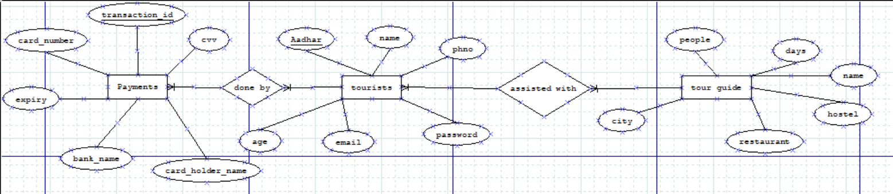

1. **Conceptual Schema:**

* **Tourist table:**

**CREATE TABLE IF NOT EXISTS tourist (**

**aadhar int not null,**

**name varchar(20) not null,**

**age int not null,**

**phno int not null,**

**email varchar(20) not null,**

**password varchar(20) not null,**

**primary key (aadhar))**

* **Guide table:**

**CREATE TABLE IF NOT EXISTS guide (**

**city varchar(50) not null,**

**guide_name varchar(20) not null,**

**restaurant varchar(20) not null,**

**hotel varchar(20) not null,**

**days int not null,**

**people int not null,**

**foreign key(aadhar) references tourist(aadhar))**

* **Payment table:**

**CREATE TABLE IF NOT EXISTS payment (**

**Transaction_id varchar(50) not null,**

**bank_name varchar(20) not null,**

**person name varchar(20) not null,**

**card number int not null,**

**cvv int not null,**

**expiry int not null,**

**primary key(transaction_id),**

**foreign key(aadhar) references tourist(aadhar))**

1. **Logical Database Design**

* **Values stored in database in each table:**

1. **Tourist table:**

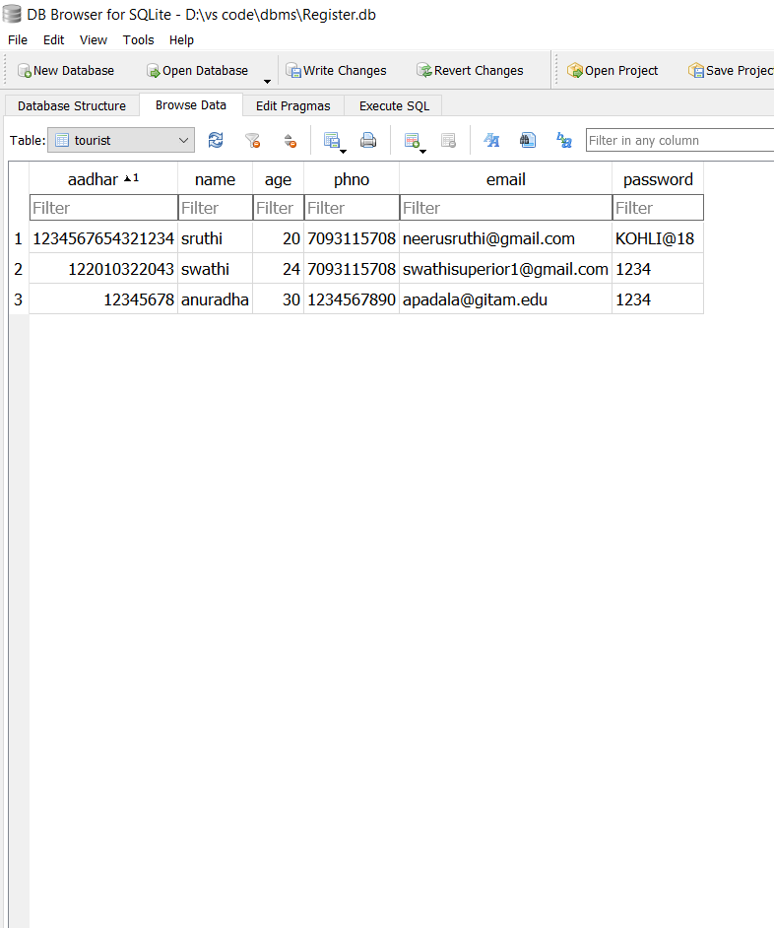

1. **Guide table:**

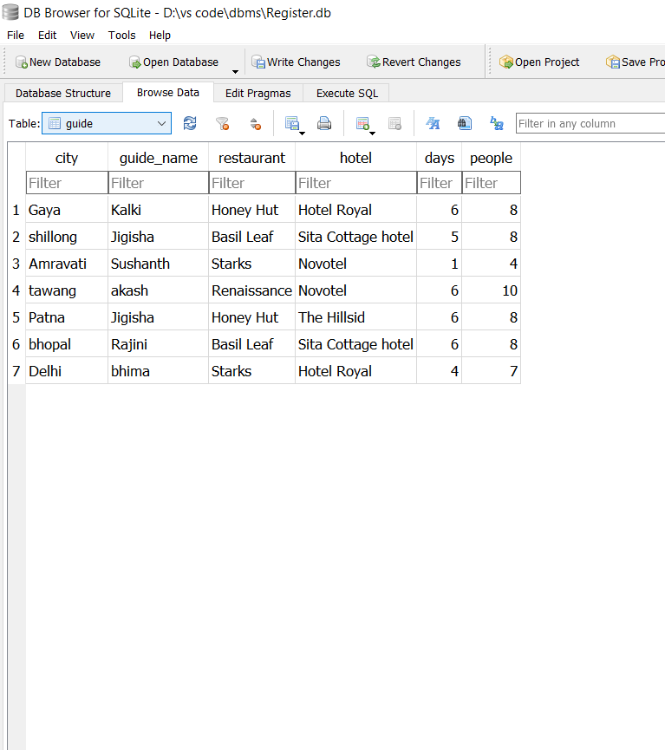

1. **Payment table:**

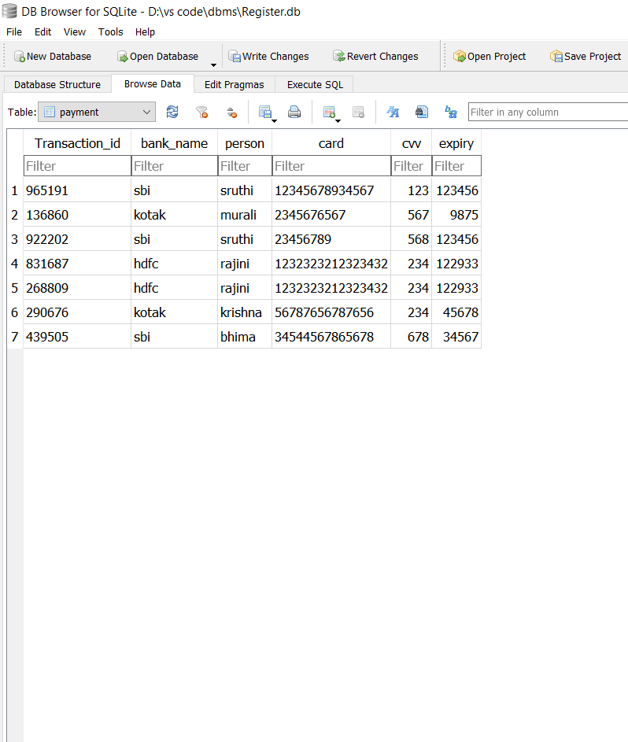

1. **TECHNOLOGIES USED:**

* **In Frontend**
* **Html – used for content writing**
* **CSS -- used for styling**

**HTML:**

* **In html, we used many tags like:**
* **<h1></h1> tag for heading – heading tag**
* **<div></div> tag for combining into a container – division tag**
* **<p></p> tag for writing a paragraph – paragraph tag**
* **<button></button> tag for creating a button – button tag**
* **<form></form> tag for taking the inputs from user – form tag**
* **<a></a> tag for inserting links – anchor tag**
* **<br></br> used for breaking the line – Line break tag**
* **<hr></hr> used to draw a horizontal line in between – horizontal rule tag**
* **<span></span> tag is an inline container used to mark up a part of a text. – span tag**
* **<label></label> tag is used to provide a usability improvement for mouse users – label tag**
* **<select></select> tag for selecting options – select tag**
* **<option></option> tag for giving the options – option tag (only used inside select tag)**
* **<body></body> tag for the whole body of html – body tag**
* **<html></html> tag for the whole page of html – html tag**
* **In html, we used html void elements like:**
* **<img src =””/> used for image – image void element (A void element is a html tag which has no end tag, it specifies both in start tag itself)**

**CSS:**

1. **For text styling:**
   * + **font-size**
     + **font-family**
     + **font-weight**
     + **color**
2. **For background styling:**

* **Background-image**
* **Background-size**
* **Background-color**

1. **For button styling:**

* **Width**
* **Height**
* **Color**
* **Border-radius**
* **Border-outline**
* **Border-color**
* **Backend**
* **In backend, we imported flask web framework to connect with frontend**
* **We also used cursors to retrieve the tuples**
* **We used @app.route routers to move to next page of website**
* **We used sqlite3 for database**
* **We used render template to render specific data**
* **We used GET and POST methods , as GET is used to retrieve the data from database and POST is used to insert the data into database**
* **We also used random module to randomly generate transaction id during payment**
* **We imported smtplib to sent the mail for OTP after verification. Login(), startls() functions are used from smtplib**

1. **Process of using website:**

* **Basically, our Tourism website enables the tourist to first create an account by entering all the details and the mail id provided will be verified and OTP will be sent, and then login with email and password.**
* **After login, tourist will be taken to the home page where they can select all the states among India.**
* **Then it goes to next page where they can select the city in that particular state, restaurant in that city, roomstay(hotel) in that city, number of days they live, number of people for the trip(minimum of 4).**
* **Then it goes to next page where tourist does payment with bank name, card holder’s name, card number, expiry, cvv.**
* **If all the details are correct then payment will be completed and then goes to next page displaying payment successful.**